Tutorial 9
- Describe 4 advantages of Wireless Networks.
- Describe 4 issues associated with Wireless Networks.
- Distinguish between the following types of wireless networks:
  - PAN
  - LAN
  - MAN
  - WAN
- What is the Industrial, Scientific, and Medical (ISM) Band?
- Distinguish between the IEEE 802.11 (Wi-Fi) and the IEEE 802.3 (Ethernet) under the following headings: -
  - Physical Layer
  - Media access
  - Availability
  - Signal Interference
  - Regulation
- What is meant by the hidden node problem in wireless LAN networks.
- What is an atomic operation in wireless LANs?
- Describe the operation of CSMA/CA as used in IEEE 802.11
- Describe the following IEEE 802.11 frame types:
  - Management
  - Control
  - Data
- Given the IEEE 802.11 frame format shown below. Indicate why multiple address fields are necessary.
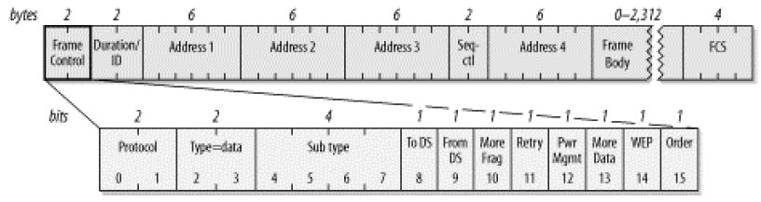
Figure 1 IEEE 802.11 frame format
- Indicate the function of the NAV in IEEE 802.11 frames.
- Describe why it can be advantageous to fragment large frames in IEEE 802.11 networks.

